Assignment 1:

PROBLEM STATEMENT:
Write a program in C to check whether a given year is a Leap Year #include<stdio.h>
int main(){
int year;
printf("Enter a year: "); scanf("%d", &year); if(year % 400 == 0){
printf("The year is a Leap year");
}
else if(year % 4 == 0 && year % 100 != 0){ printf("The year is a Leap year");

}
else{

}

printf("The year is not a Leap year");

return(0);
}

PROBLEM STATEMENT:
Write a menu driven program in C to implement the basic arithmetic operations such as Addition, Subtraction, Multiplication, and Division.

#include <stdio.h> #include <math.h>

void main(){
char op;
int num1, num2; printf("Calculator Operation:\n"); printf(" +, -, * , /\n");
printf("Enter an operator: "); scanf("%c", &op); printf("Enter a number: "); scanf("%f", &num1);
printf("Enter another number: "); scanf("%f", &num2);
switch(op){
case('+'):
printf("Result = %.2f",(num1 + num2)); break;
case('-'):
printf("Result = %.2f",num1 - num2); break;
case('*'):
printf("Result = %.2f",num1 * num2); break;
case('/'):
printf("Result = %.2f",num1 / num2); break;
case('%'):
printf("Result = %.2f",num1 % num2); break;
default:
printf("Incorrect input!");
}
}

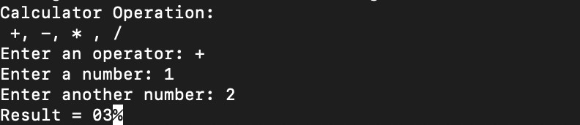

PROBLEM STATEMENT:
Write a program in C to generate multiplication tables for a given number.

#include<stdio.h> int main(){
int a = 1;
int userNum; printf("Enter a number:"); scanf("%d",&userNum); while(a <= 10){
printf("%d X %d = ", userNum, a); printf("%d\n", a*userNum);
a++;
}
}
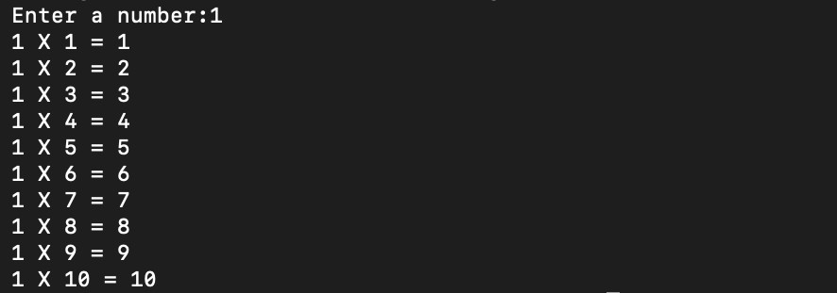

Write a C Program to calculate the salary of an employee given his basic pay (taken as input from the user). Calculate gross salary of employee. Let HRA be 10 % of basic pay and TA be 5% of basic pay. Let employees pay professional tax as 2% of total salary. Calculate net salary payable after deductions.
#include <stdio.h> int main(){
float basic, hra, ta, gross, tax, net;
printf("Enter Basic Salary: "); scanf("%f", &basic);
hra = 0.1 * basic; ta = 0.05 * basic;
gross = basic + hra + ta; tax = 0.02 * gross;
net = gross - tax;
printf("\nGross Salary = %.2f", gross); printf("\nProfessional Tax = %.2f", tax); printf("\nNet Salary = %.2f", net); return(0);
}
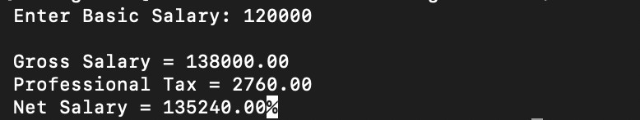

Write a program in C to perform basic matrix operations such as:
- Addition of two matrices
- Saddle point of a matrix
- Inverse of a matrix
- Magic square of a matrix #include <stdio.h>
void matrixAddition(); void findSaddlePoint(); void findInverse2x2();
void checkMagicSquare();

int main() { int choice; while(1) {
printf("\n--- Matrix Operations Menu ---"); printf("\n1. Addition of two matrices"); printf("\n2. Saddle point of a matrix"); printf("\n3. Inverse of a 2x2 matrix"); printf("\n4. Magic square check"); printf("\n5. Exit");
printf("\nEnter choice: "); scanf("%d", &choice);

switch(choice) {
case 1: matrixAddition(); break; case 2: findSaddlePoint(); break; case 3: findInverse2x2(); break; case 4: checkMagicSquare(); break; case 5: return 0;
default: printf("Invalid choice!");
}
}
}

// 1. Addition of Matrices void matrixAddition() {
int r, c, i, j;
printf("Enter rows and columns: "); scanf("%d %d", &r, &c);
int a[r][c], b[r][c], sum[r][c];

printf("Enter elements of Matrix A:\n");
for(i=0; i<r; i++) for(j=0; j<c; j++) scanf("%d", &a[i][j]);

printf("Enter elements of Matrix B:\n");
for(i=0; i<r; i++) for(j=0; j<c; j++) scanf("%d", &b[i][j]);

printf("Resultant Matrix:\n"); for(i=0; i<r; i++) {
for(j=0; j<c; j++) {
sum[i][j] = a[i][j] + b[i][j]; [cite: 57] printf("%d ", sum[i][j]);
}
printf("\n");
}
}

// 2. Saddle Point (Min in Row, Max in Col) void findSaddlePoint() {
int n, i, j, k, min_row, col_ind, flag = 0; printf("Enter order of square matrix: "); scanf("%d", &n);
int mat[n][n];

printf("Enter elements:\n");
for(i=0; i<n; i++) for(j=0; j<n; j++) scanf("%d", &mat[i][j]);

for(i=0; i<n; i++) { min_row = mat[i][0]; col_ind = 0;
for(j=1; j<n; j++) { if(mat[i][j] < min_row) {
min_row = mat[i][j]; col_ind = j;
}
}
for(k=0; k<n; k++) {
if(mat[k][col_ind] > min_row) break; if(k == n-1) {
printf("Saddle Point found: %d\n", min_row); [cite: 58] flag = 1;
}
}
}

if(!flag) printf("No Saddle Point exists.\n");
}

// 3. Inverse of 2x2 Matrix void findInverse2x2() {
float a[2][2], det;
printf("Enter elements of 2x2 matrix:\n");
for(int i=0; i<2; i++) for(int j=0; j<2; j++) scanf("%f", &a[i][j]);

det = (a[0][0] * a[1][1]) - (a[0][1] * a[1][0]); [cite: 59]

if(det == 0) {
printf("Inverse does not exist (Determinant is 0).\n"); [cite: 59]
} else {
printf("Inverse Matrix:\n");
printf("%.2f %.2f\n", a[1][1]/det, -a[0][1]/det);
printf("%.2f %.2f\n", -a[1][0]/det, a[0][0]/det);
}
}

// 4. Magic Square Check void checkMagicSquare() {
int n, i, j, sumD1=0, sumD2=0, flag=0; printf("Enter order of matrix: "); scanf("%d", &n);
int mat[n][n], rowSum[n], colSum[n];

printf("Enter elements:\n"); for(i=0; i<n; i++) {
rowSum[i] = 0; for(j=0; j<n; j++) {
scanf("%d", &mat[i][j]);
}
}

for(i=0; i<n; i++) { for(j=0; j<n; j++) {
rowSum[i] += mat[i][j];
if(i == j) sumD1 += mat[i][j];
if(i + j == n - 1) sumD2 += mat[i][j];
}
}

for(j=0; j<n; j++) {

colSum[j] = 0;
for(i=0; i<n; i++) colSum[j] += mat[i][j];
}

for(i=0; i<n; i++) {
if(rowSum[i] != sumD1 || colSum[i] != sumD1) flag = 1; [cite: 60]
}

if(flag == 0 && sumD1 == sumD2) printf("It is a Magic Square.\n"); [cite: 60] else printf("Not a Magic Square.\n");
}

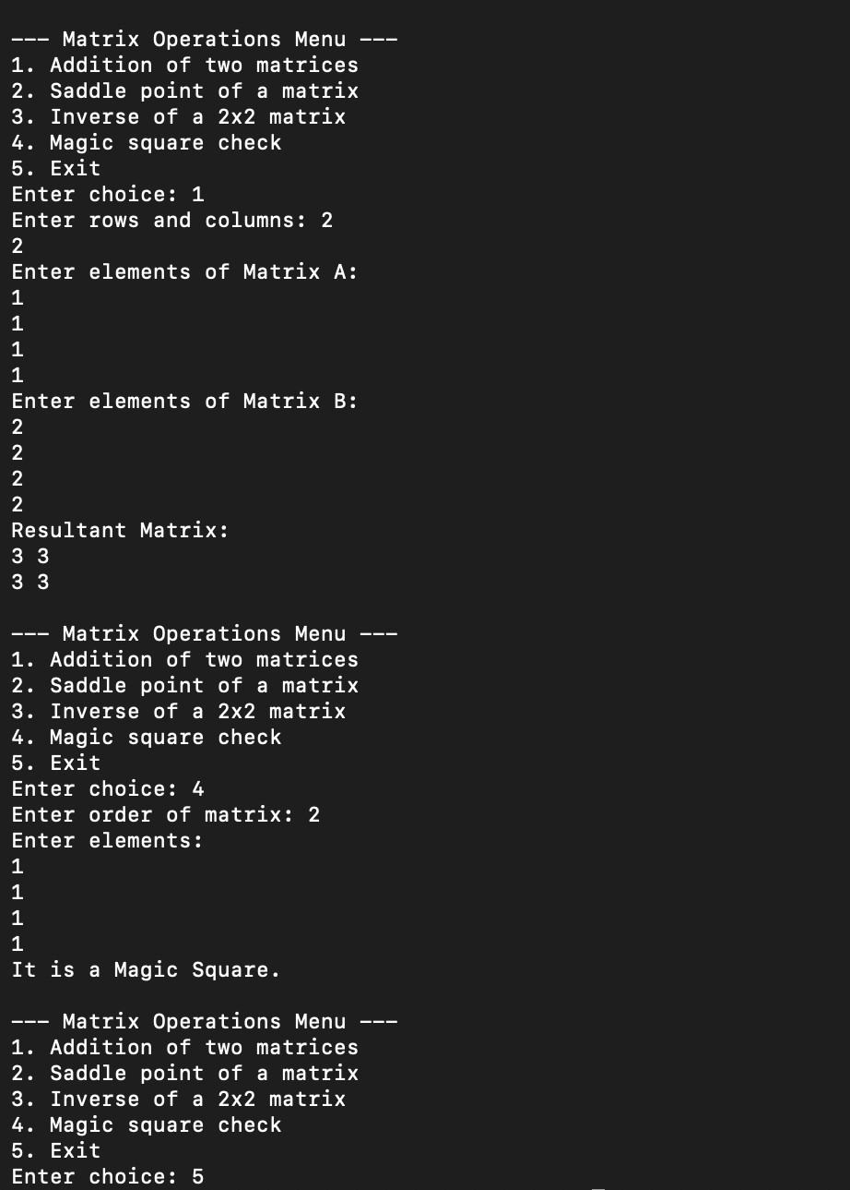

Write a C function to compute the factorial of a number with and without recursion.
#include<stdio.h> int factorial(int num){
int result = num;
for(int i = num - 1; i>0; i--){ result = result * i;
}
return(result);
}
int recursiveFactorial(int n) { if (n == 0 || n == 1){
return 1;
}
else{
return n * recursiveFactorial(n - 1);
}
}

int main(){
int num = 5;
printf("%d", factorial(num)); printf("\n%d", recursiveFactorial(num));

}

Write a C program to accept student details and display their result using an array of structures. #include<stdio.h>
typedef struct student { char name[50];
int PRN, M1, M2, M3;
float percentage;
} student;

int main() { int i, n;

printf("Enter number of students: "); scanf("%d", &n);

student S[n];

for(i = 0; i < n; i++) {
printf("\nEnter details of student %d\n", i + 1);

printf("Name: ");
scanf(" %[^\n]", S[i].name);

printf("PRN: "); scanf("%d", &S[i].PRN);

printf("Marks (3 subjects): ");
scanf("%d %d %d", &S[i].M1, &S[i].M2, &S[i].M3);

S[i].percentage = (S[i].M1 + S[i].M2 + S[i].M3) / 3.0;
}

printf("\n--- STUDENT RESULTS ---\n");

for(i = 0; i < n; i++) { printf("\nName: %s", S[i].name);
printf("\nPRN: %d", S[i].PRN); printf("\nPercentage: %.2f", S[i].percentage);

if(S[i].percentage >= 75){ printf("\nResult: Distinction");

}
else if(S[i].percentage >= 60){ printf("\nResult: First Class");
}
else if(S[i].percentage >= 50){ printf("\nResult: Second Class");
}
else if(S[i].percentage >= 40){ printf("\nResult: Pass");
}
else{
printf("\nResult: Fail");
}
}
return 0;
}

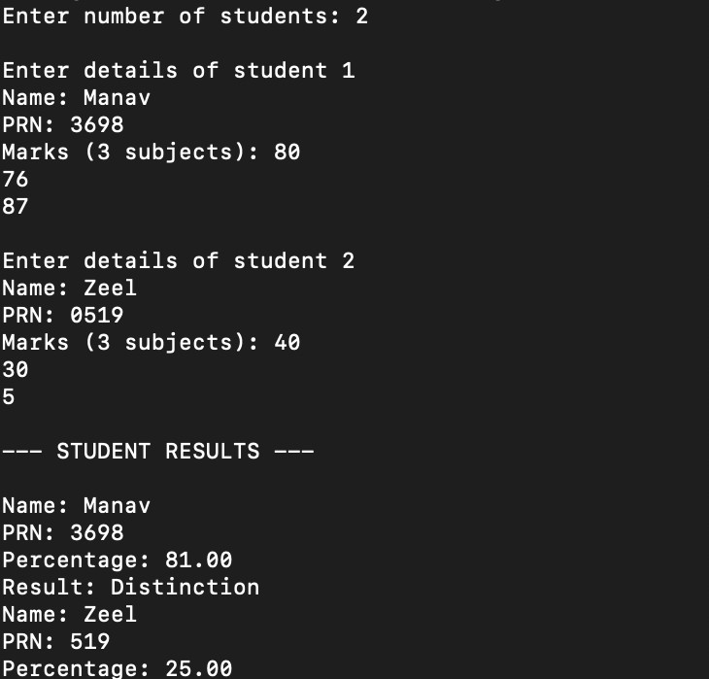

Assignment 8:

PROBLEM STATEMENT:
Write a program in C to accept marks of five courses of a student and compute the result. A student is considered PASS if he/she scores 40 marks or more in each course. If the student passes, calculate the aggregate percentage and assign the grade as follows:
- Aggregate ≥ 75% : Distinction
- Aggregate ≥ 60% and < 75% : First Division
- Aggregate ≥ 50% and < 60% : Second Division
- Aggregate ≥ 40% and < 50% : Third Division
#include <stdio.h>

typedef struct student { char name[50];
int marks[5]; float percentage;
} student;

int main() { int i, j, n;

printf("Enter number of students: "); scanf("%d", &n);

student S[n];

for(i = 0; i < n; i++) {
printf("\nEnter name of student %d: ", i + 1); scanf(" %[^\n]", S[i].name);

printf("Enter marks of 5 subjects:\n"); for(j = 0; j < 5; j++) {
scanf("%d", &S[i].marks[j]);
}

// Calculate percentage int sum = 0;
for(j = 0; j < 5; j++) { sum += S[i].marks[j];
}

S[i].percentage = sum / 5.0;
}
printf("\n--- RESULT ---\n"); for(i = 0; i < n; i++) {
int pass = 1;

for(j = 0; j < 5; j++) { if(S[i].marks[j] < 40) {
pass = 0; break;
}
}

printf("\nName: %s", S[i].name); printf("\nPercentage: %.2f", S[i].percentage);

if(pass == 0) { printf("\nResult: Fail");
} else {
// Grade classification if(S[i].percentage > 75)
printf("\nGrade: Distinction"); else if(S[i].percentage >= 60)
printf("\nGrade: First Division"); else if(S[i].percentage >= 50)
printf("\nGrade: Second Division"); else if(S[i].percentage >= 40)
printf("\nGrade: Third Division");
}

printf("\n \n");
}

return 0;
}

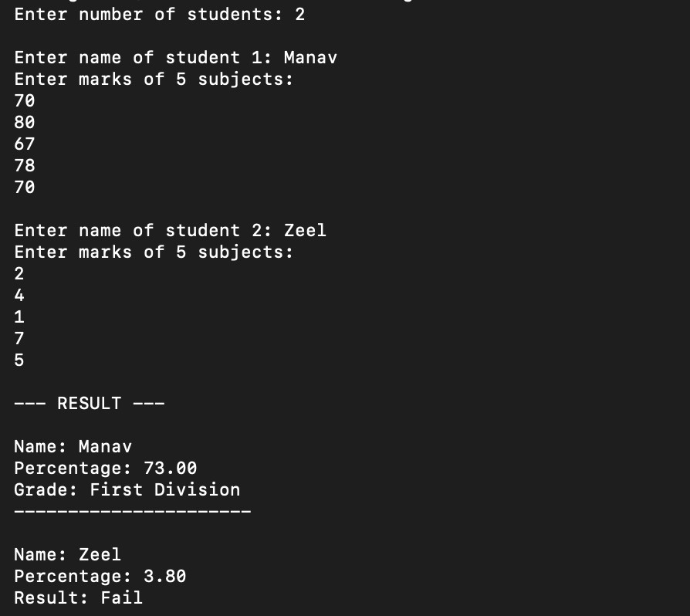

Write a program in C to check whether the given number is an Armstrong number or not.
An Armstrong number is an integer with three digits such that the sum of the cubes of its digits is equal to the number itself.
Example: 371 #include<stdio.h>

int main(){
int userNum, units, tens, hundreds; printf("Enter a number: "); scanf("%d", &userNum);
units = userNum % 10;
tens = (userNum % 100 - units) / 10;
hundreds = (userNum - (tens * 10) - units)/100;
if(((units*units*units) + (tens*tens*tens) + (hundreds*hundreds*hundreds)) == userNum){ printf("It is an Armstromg Number!");

}
else{

}
}

printf("It is not an Armstrong Number");

Write a program in C to simulate a simple calculator that performs basic arithmetic operations such as addition, subtraction, multiplication, and division. The calculator should also perform special operations like computing xʸ (power) and x! (factorial).
#include <stdio.h>

void main(){
char op;
int num1, num2; printf("Calculator Operation:\n"); printf("+ , - , * , / , ^ , !\n"); printf("Enter an operator: "); scanf("%c", &op);
printf("Enter a number: "); scanf("%d", &num1); printf("Enter another number: "); scanf("%d", &num2); switch(op){
case('+'):
printf("Result = %.2f",(num1 + num2)); break;
case('-'):
printf("Result = %.2f",num1 - num2); break;
case('*'):
printf("Result = %.2f",num1 * num2); break;
case('/'):
if(num1 == 0 || num2 == 0){
printf("Numbers cannot be 0 for division");

}
else{

}
break; case('%'):

printf("Result = %.2f",num1 / num2);

printf("Result = %.2f",num1 % num2); break;
case('^'):
int result = num1; if(num2 == 0){

printf("result = 1");
}
else{
for(int i = 1; i < num2; i++){ result = num1*result;

default:

}
}
}
printf("Result = %d", result);
}
break;

printf("Incorrect input!"); break;

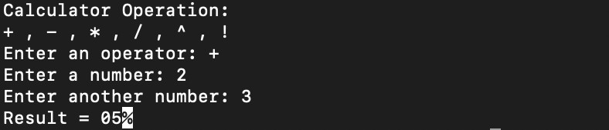

Assignment 11:

PROBLEM STATEMENT:
Write a program in C to accept a number from the user and compute the following:
  - Square root of the number
  - Square of the number
  - Cube of the number
  - Check whether the number is prime
  - Factorial of the number
  - Prime factors of the number

#include <stdio.h> #include <math.h>

int isPrime(int n) { if(n < 2) return 0;
for(int i = 2; i <= sqrt(n); i++) { if(n % i == 0)
return 0;
}
return 1;
}

long long factorial(int n) { long long fact = 1; for(int i = 1; i <= n; i++)
fact *= i; return fact;
}

void primeFactors(int n) { for(int i = 2; i <= n; i++) {
while(n % i == 0) { printf("%d ", i); n /= i;
}
}
}

int main() { int n;

printf("Enter a number: ");

scanf("%d", &n);

printf("Square root: %.2f\n", sqrt(n)); printf("Square: %d\n", n * n); printf("Cube: %d\n", n * n * n);

if(isPrime(n)) printf("Prime: Yes\n");
else
printf("Prime: No\n");

printf("Factorial: %lld\n", factorial(n));

printf("Prime Factors: "); primeFactors(n);

return 0;
}
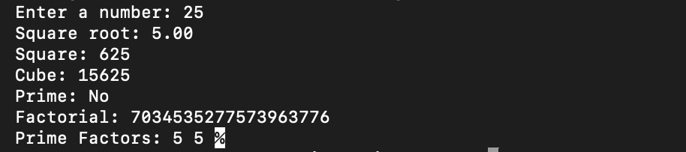

Assignment 12:

PROBLEM STATEMENT:
Write a program in C to accept two numbers from the user and compute:

- The smallest common divisor of the two numbers (other than 1, if any)

- The Greatest Common Divisor (GCD) of the two numbers #include <stdio.h>
int smallestDivisor(int n) { if(n < 0) n = -n;
if(n == 0) return 0;
for(int i = 2; i <= n; i++) { if(n % i == 0)
return i;
}
return n;
}

int gcd(int a, int b) { if(a < 0) a = -a;
if(b < 0) b = -b;
while(b != 0) { int temp = b; b = a % b;
a = temp;
}
return a;
}

int main() { int a, b;

printf("Enter two numbers: "); scanf("%d %d", &a, &b);

printf("Smallest divisor of %d: %d\n", a, smallestDivisor(a)); printf("Smallest divisor of %d: %d\n", b, smallestDivisor(b));

printf("GCD of %d and %d: %d\n", a, b, gcd(a, b));

return 0;
}

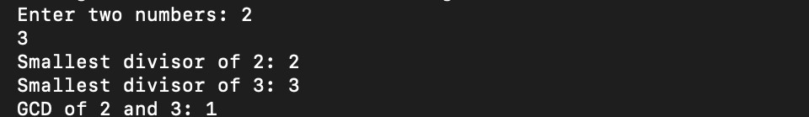

Write a program in C to accept a number from the user and print the digits of the number in reverse order.

#include<stdio.h> int main(){
int num;
int temp;
int reversed = 0; printf("Enter a number: "); scanf("%d",&num); while(num!= 0){
temp = num % 10;
reversed = (reversed * 10) + temp; num = num/10;
}
printf("The reversed number is:\n %d\n",reversed);
}

Write a C program to input a binary number from the user and convert it into a decimal number.

#include<stdio.h> #include<math.h> int main(){
int binNum; int temp;
printf("Enter the four digit Binary Number: "); scanf("%d",&binNum);
temp = binNum; while(temp!=0){
if (temp%10 == 1 || temp%10 == 0){ temp/=10;

}
else{

}
}

printf("invalid input"); return(0);

int decimal = 0; int i = 0;
while(binNum!=0){
decimal = decimal + (binNum%10*pow(2,i)); binNum /= 10;
i++;
}
printf("\nThe Decimal Number is: %d\n",decimal);
}

Write a C program to generate pseudo random numbers. #include <stdio.h>
#include <stdlib.h> #include <time.h>

int main() { int n, i;
srand(time(0));

printf("Enter how many random numbers you want: "); scanf("%d", &n);

printf("Pseudo Random Numbers:\n"); for (i = 0; i < n; i++) {
printf("%d ", rand());
}

printf("\n"); return 0;
}
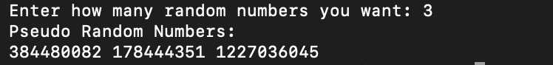

To accept a list of N integers and partition the list into two sublists containing even and odd numbers. #include <stdio.h>
int main() { int n, i;

printf("Enter number of elements: "); scanf("%d", &n);

int arr[n];

printf("Enter integers: "); for (i = 0; i < n; i++) {
scanf("%d", &arr[i]);
}

printf("Even numbers are: "); for (i = 0; i < n; i++) {
if (arr[i] % 2 == 0) { printf("%d ", arr[i]);
}
}

printf("\nOdd numbers are: "); for (i = 0; i < n; i++) {
if (arr[i] % 2 != 0) {
printf("%d ", arr[i]);
}
}

printf("\n"); return 0;
}
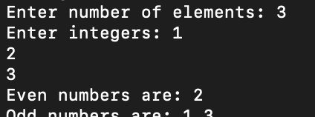

To accept the number of terms and find the sum of the sine series. #include <stdio.h>
#include <math.h>

long long factorial(int n) { long long fact = 1;
for (int i = 1; i <= n; i++) fact *= i;
return fact;
}

int main() {
double x, sum = 0, term; int n, i;

printf("Enter value of x (in radians): "); scanf("%lf", &x);
printf("Enter number of terms: "); scanf("%d", &n);

for (i = 0; i < n; i++) { int power = 2 * i + 1;
term = pow(x, power) / factorial(power);

if (i % 2 == 0) {
sum += term;
} else {
sum -= term;
}
}

printf("Sum of sine series = %lf\n", sum);

return 0;
}
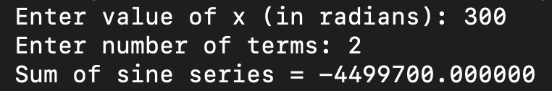

Write a C program that accepts a string from the user and performs the following string operations: i) Calculate length of string ii) String reversal iii) Equality check of two strings iv) Check palindrome v) Check substring.
#include <stdio.h> #include <string.h>

int main() {
char str1[100], str2[100], temp[100];

printf("Enter main string: "); scanf(" %[^\n]", str1); printf("Enter second string: "); scanf(" %[^\n]", str2);
printf("\nLength of string: %lu", strlen(str1)); [cite: 203] strcpy(temp, str1);
int len = strlen(temp);
for(int i = 0; i < len/2; i++) { char t = temp[i];
temp[i] = temp[len-1-i];
temp[len-1-i] = t;
}
printf("\nReversed string: %s", temp);

if (strcmp(str1, str2) == 0) [cite: 186] printf("\nStrings are equal");
else
printf("\nStrings are not equal");

if (strcmp(str1, temp) == 0) printf("\nPalindrome: Yes");
else
printf("\nPalindrome: No");

if (strstr(str1, str2) != NULL) [cite: 205] printf("\nSubstring: Found");
else
printf("\nSubstring: Not Found");

printf("\n"); return 0;

}
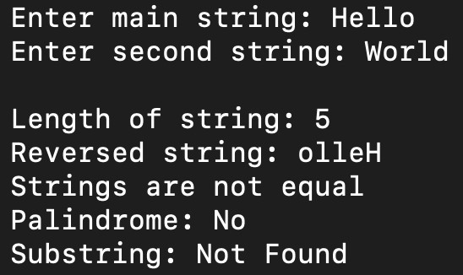

Assignment 19:

PROBLEM STATEMENT:
Create Structure EMPLOYEE for storing details (Name, Designation, gender, Date of Joining and Salary). Define function members to compute a) total number of employees in an organization b) count of male and female employee c) Employee with salary more than 10,000 d) Employee with designation “Asst Manager”

#include <stdio.h> #include <string.h>

struct EMPLOYEE { char name[50];
char designation[50]; char gender;
char doj[15]; float salary;
};

int main() { int n, i;
int maleCount = 0, femaleCount = 0; int asstManagerCount = 0;

printf("Enter number of employees: "); scanf("%d", &n);
struct EMPLOYEE emp[n]; for (i = 0; i < n; i++) {
printf("\n--- Employee %d ---\n", i + 1);
printf("Name: "); scanf("%s", emp[i].name);
printf("Designation (e.g., Asst_Manager): "); scanf("%s", emp[i].designation); printf("Gender (M/F): "); scanf(" %c", &emp[i].gender);
printf("DOJ (DD/MM/YYYY): "); scanf("%s", emp[i].doj);
printf("Salary: "); scanf("%f", &emp[i].salary);
}

printf("\n--- RESULTS ---\n"); printf("Total Employees: %d\n", n);
printf("Employees with Salary > 10,000:\n"); for (i = 0; i < n; i++) {

if (emp[i].gender == 'M' || emp[i].gender == 'm') maleCount++; else if (emp[i].gender == 'F' || emp[i].gender == 'f') femaleCount++;

if (emp[i].salary > 10000) {
printf(" - %s (%.2f)\n", emp[i].name, emp[i].salary);
}

if (strcmp(emp[i].designation, "Asst_Manager") == 0) { asstManagerCount++;
}
}

printf("Male Employees: %d | Female Employees: %d\n", maleCount, femaleCount); printf("Employees with designation 'Asst_Manager': %d\n", asstManagerCount);

return 0;
}
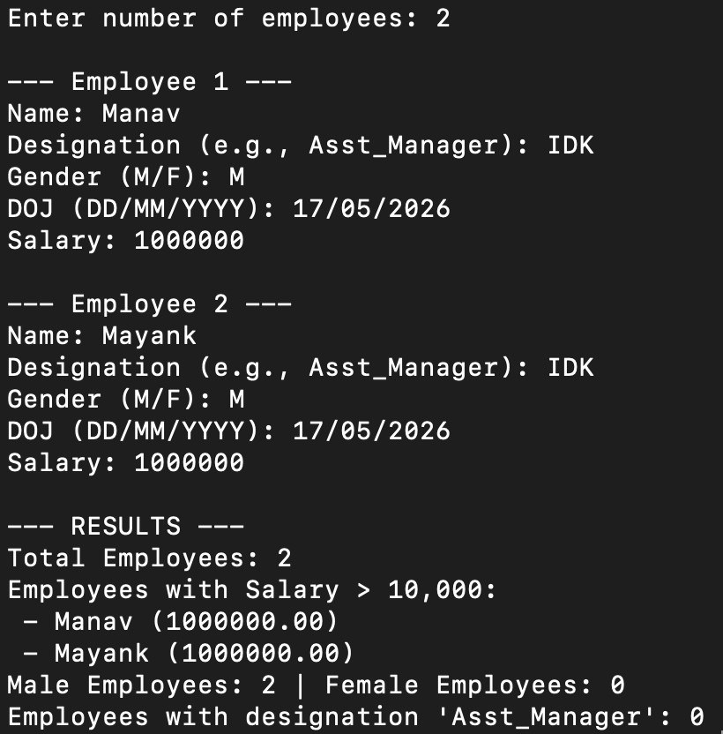

Assignment 20:

PROBLEM STATEMENT:
Write a C function to swap two numbers with and without using pointers. #include <stdio.h>
void swap_value(int a, int b) { int temp;
temp = a;
a = b;
b = temp;
printf("After swapping without pointers:\n"); printf("a = %d b = %d\n", a, b);
}

void swap_pointer(int *x, int *y) { int temp;
temp = *x;
*x = *y;
*y = temp;
}

int main() { int a, b;

printf("Enter two numbers: "); scanf("%d %d", &a, &b);

swap_value(a, b); swap_pointer(&a, &b);
printf("After swapping with pointers:\n"); printf("a = %d b = %d\n", a, b);

return 0;
}

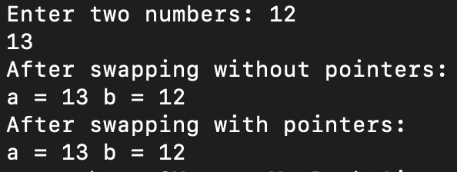

Write a C program to copy contents of one file to another using file handling. #include <stdio.h>
int main() {
FILE *source, *destination; char ch;
source = fopen("source.txt", "r"); if (source == NULL) {
printf("Error opening source file.\n");
return 1;
}
destination = fopen("destination.txt", "w"); if (destination == NULL) {
printf("Error opening destination file.\n"); fclose(source);
return 1;
}

while ((ch = fgetc(source)) != EOF) { fputc(ch, destination);
}
printf("File copied successfully.\n"); fclose(source);
fclose(destination);

return 0;
}
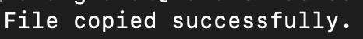

Write a menu driven program in C to perform various string operations using in-built functions.

#include <stdio.h> #include <stdbool.h> #include <string.h> int main(){
int choice; char str1[20]; char str2[20];
bool verify = true; do{

Copy\n");
printf("Would you like to: \n1. Compare \n2. Concatenate\n3. Find their length \n4.

scanf("%d",&choice);
if(choice == 1||choice == 2||choice == 3||choice == 4){ verify = false;

}
else{

}
}while(verify); switch(choice){
case 1 :

printf("Invalid Input");

printf("Please enter a sentence: \n"); scanf(" %[^\n]", str1);
printf("Please enter another sentence: \n"); scanf(" %[^\n]", str2);
if(strcmp(str1,str2) == 0){
printf("The strings are equal!");

case 2 :
}
else{

}
break;

printf("The strings are not equal");

printf("Please enter a sentence: \n"); scanf(" %[^\n]", str1);
printf("Please enter another sentence: \n"); scanf(" %[^\n]", str2);
printf("New string is:\n %s", (strcat(str1,str2))); break;

case 3 :

case 4 :

}

printf("Please enter a sentence: \n"); scanf(" %[^\n]", str1);
printf("The length of the string is: %lu", (strlen(str1))); break;

printf("Please enter a sentence: \n"); scanf(" %[^\n]", str1); strcpy(str2,str1);
printf("%s is scored in str2", (str2)); break;

}
